**Spring Testing Exercises**

**Exercise 1: Basic Unit Test for a Service Method**

Task: Write a unit test for a service method that adds two numbers.

Service:

@Service public class CalculatorService {

public int add(int a, int b) {

return a + b; } }

Test: Write code for this.

**SOLUTION:**

**CalculatorService.java:**

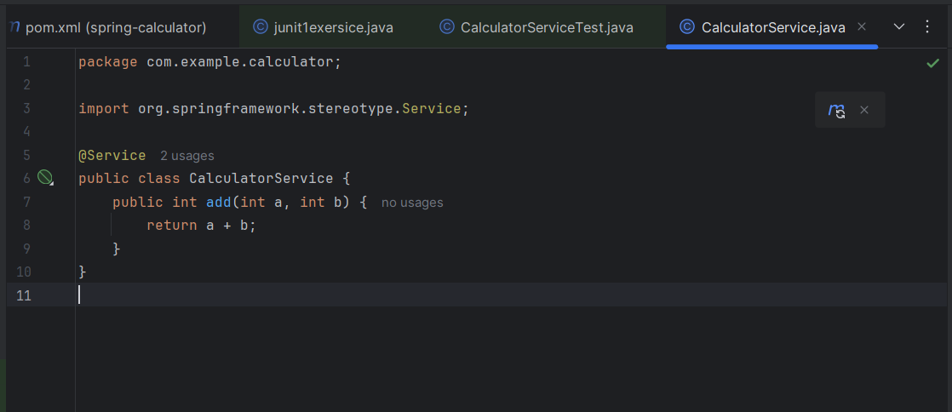

**CalculatorServiceTest.java:**

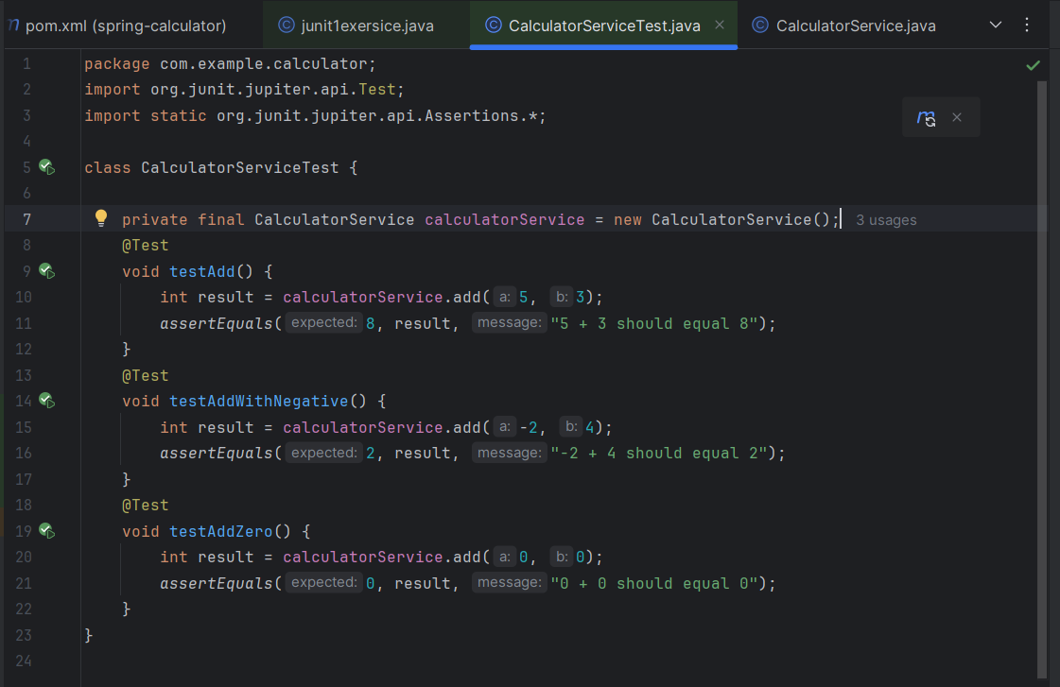

**OUTPUT:**

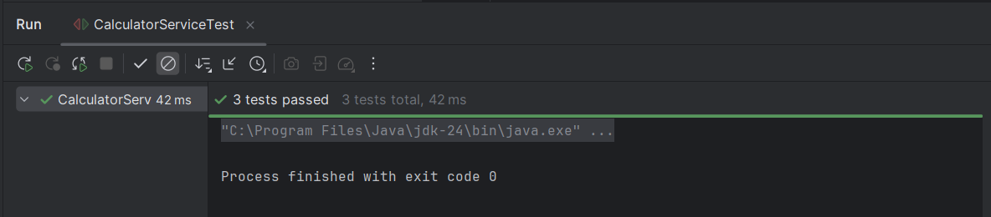

**Exercise 2: Mocking a Repository in a Service Test**

Task: Test a service that uses a repository to fetch data.

Entity:

@Entity

public class User {

@Id

private Long id;

private String name;

// getters and setters }

Repository:

public interface UserRepository extends JpaRepository {

}

Service:

@Service public class UserService {

@Autowired

private UserRepository userRepository;

public User getUserById(Long id) {

return userRepository.findById(id).orElse(null);

} }

Test:

Write code for this**.**

**SOLUTION:**

**UerRepository.java:**

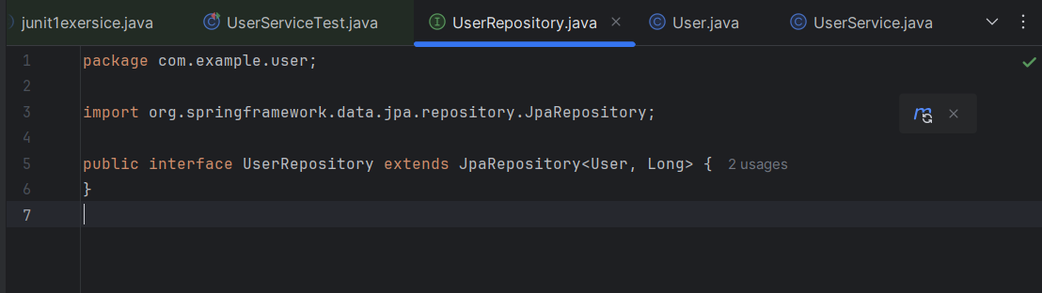

**User.java:**

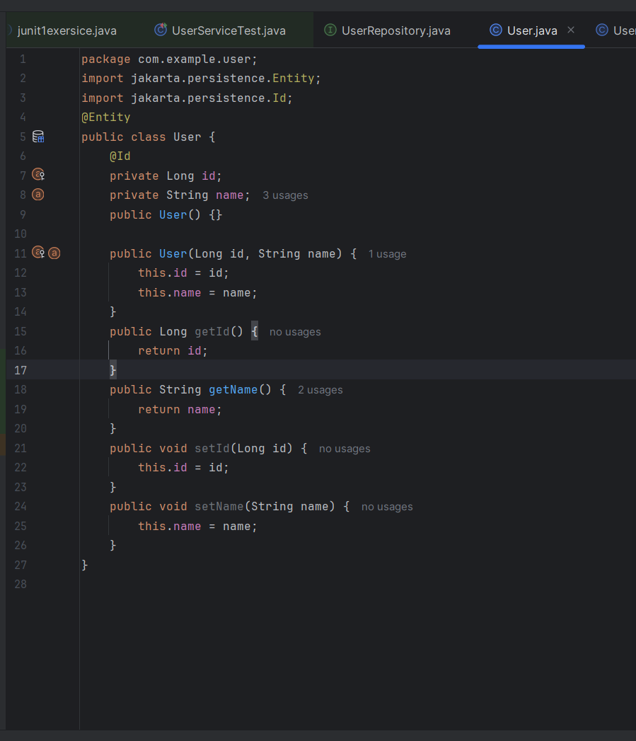

**UserService.java:**

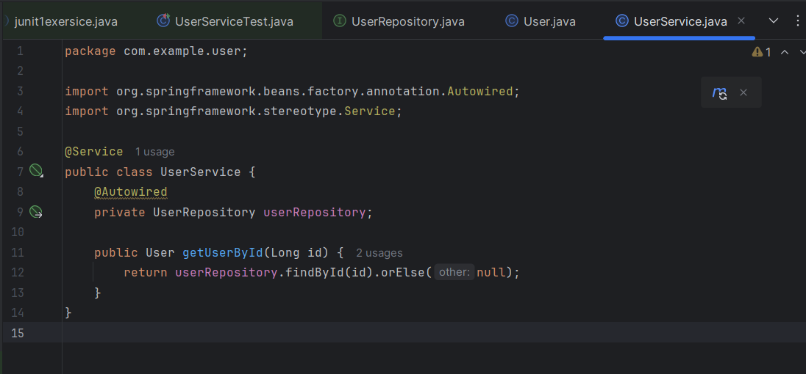

**UserServiceTest.java:**

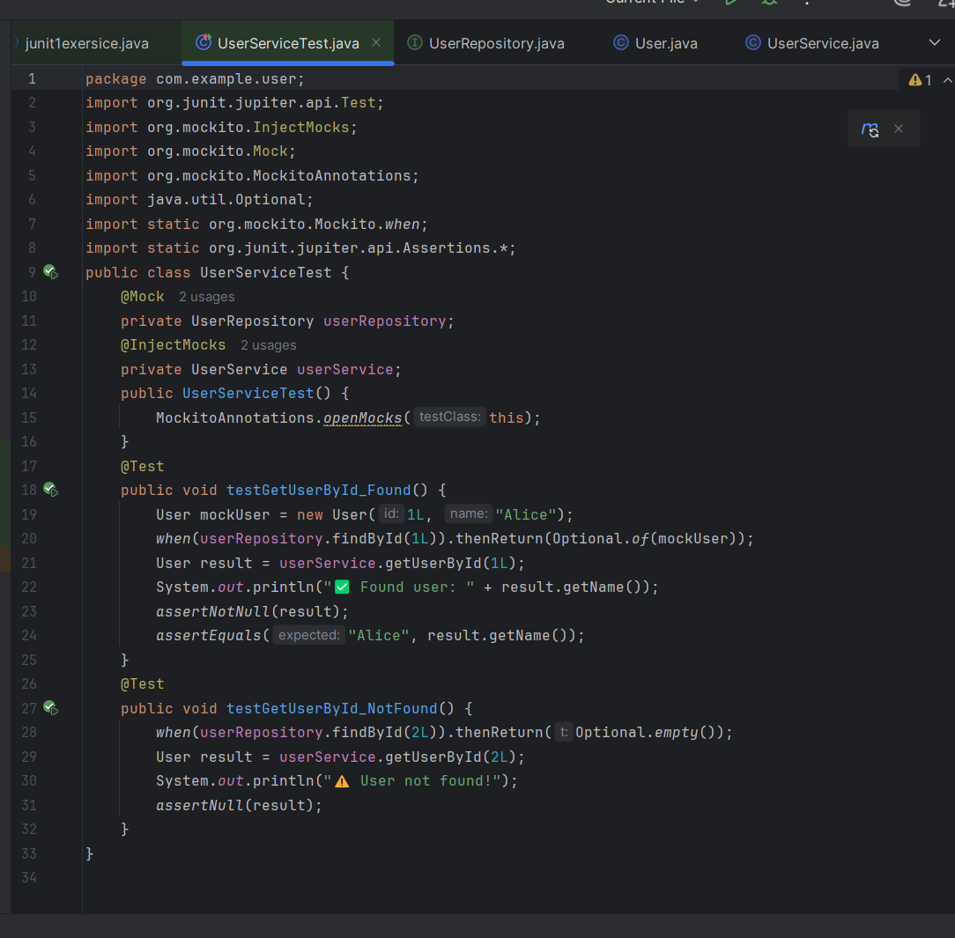

**OUTPUT:**

